354

* Download and install tableau prep
* Open tableau prep builder application
* 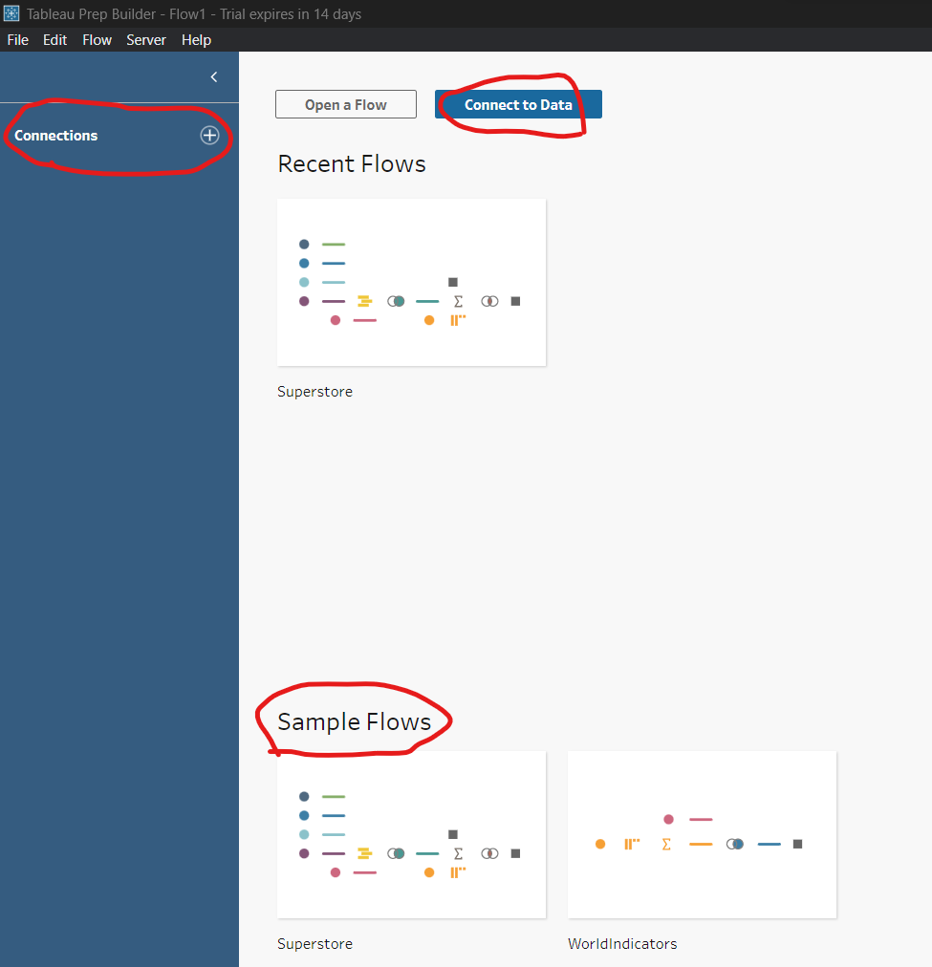
* 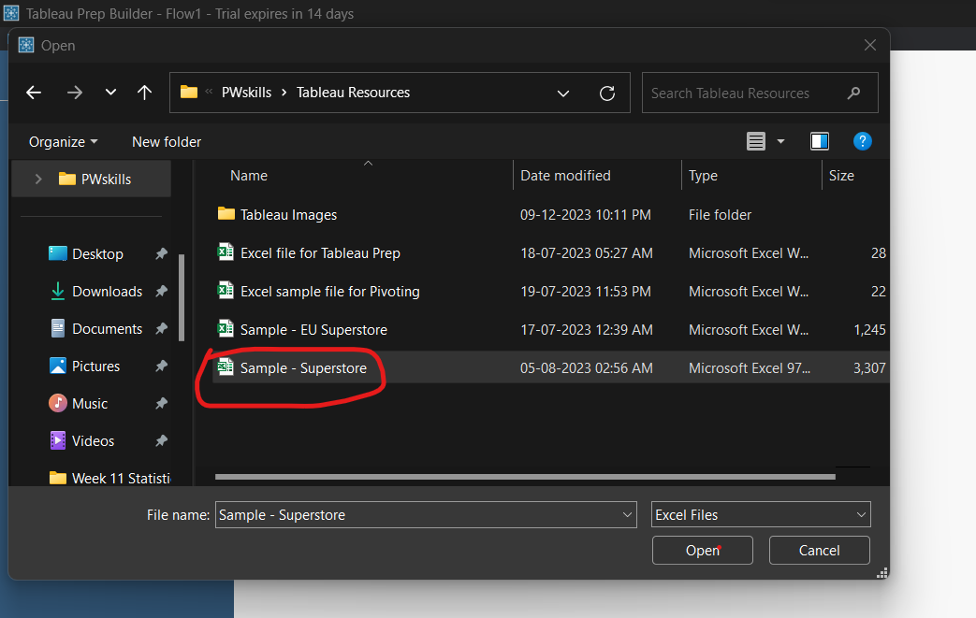
* 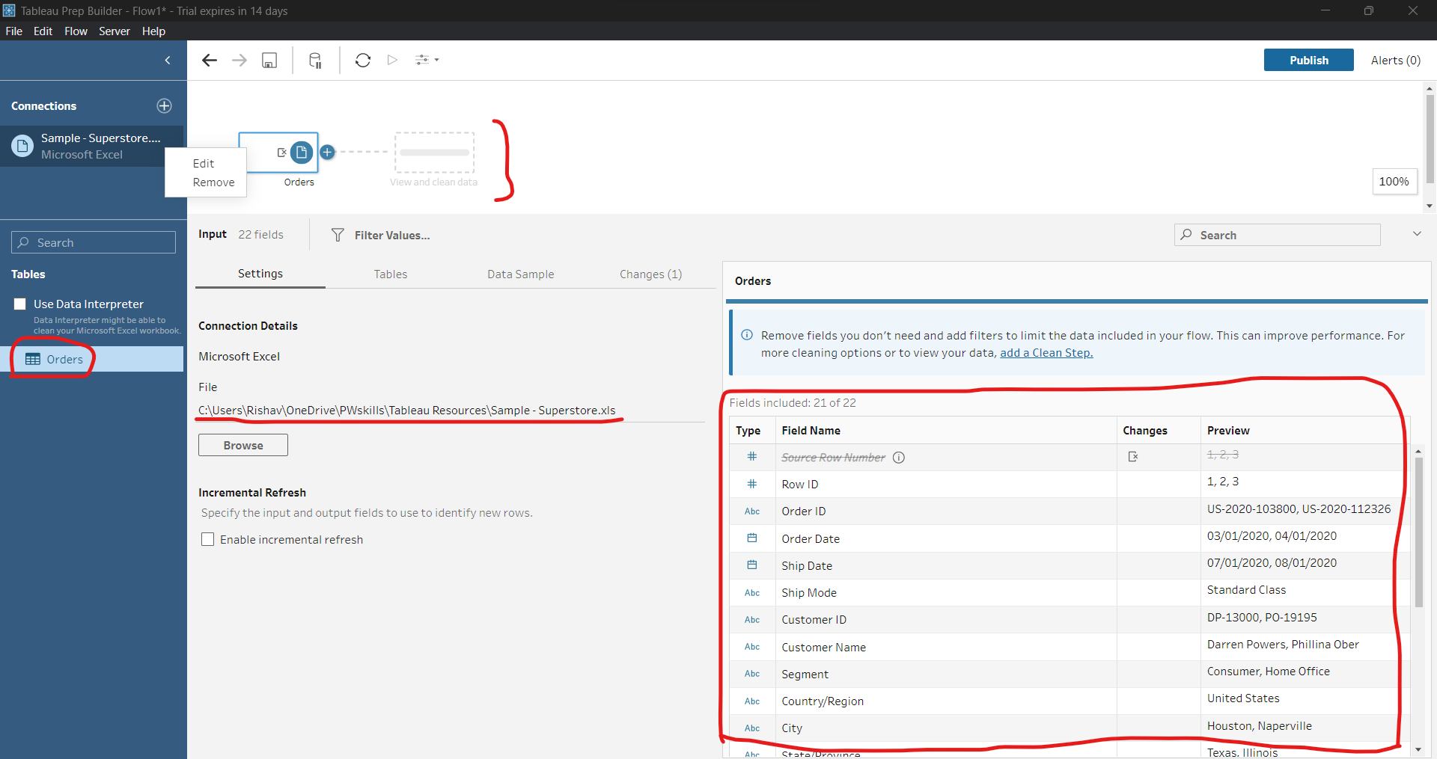
* We can add more files from browse. For joining two or more tables.
* Double click on table to add in workflow area.
* Click on tables workflow to niche ka area show hoga.
* 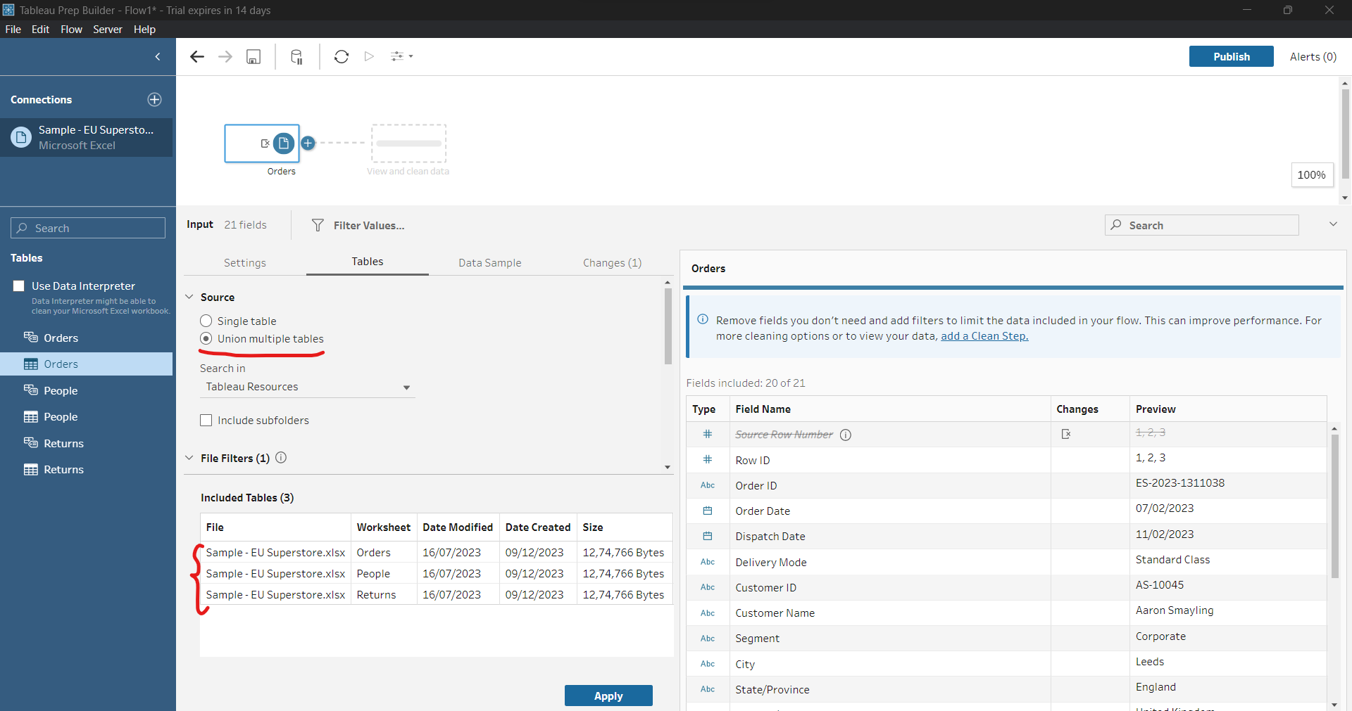
* Apply pe click karne pe teeno hi table combine ho jaayegi.
* But for now, I will work on single table.
* 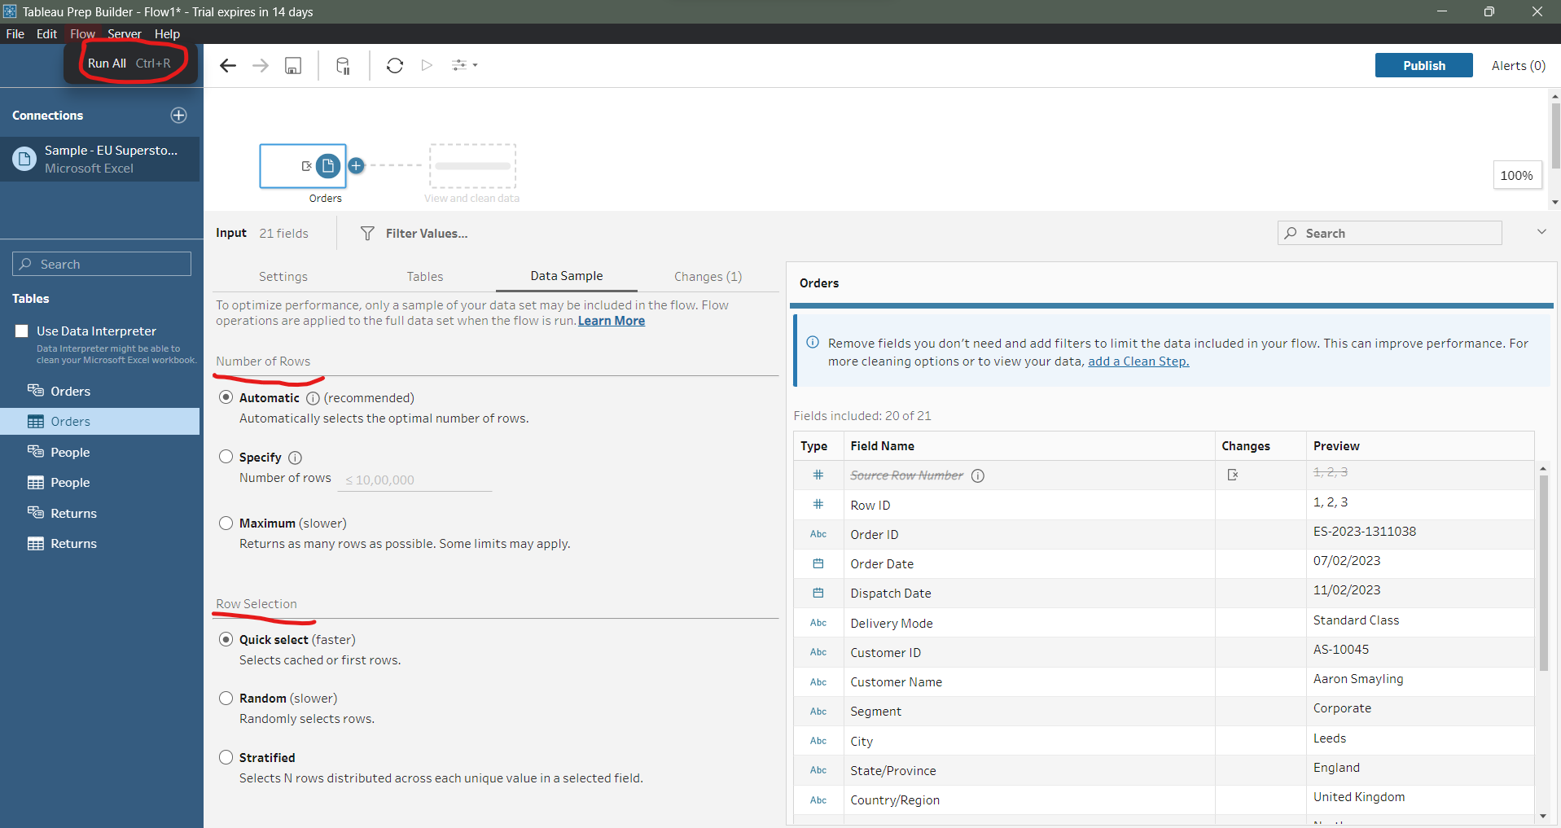
* Data sample me number of rows select karte hai.
* Flow -> Run All se saara row select ho jaayega.
* 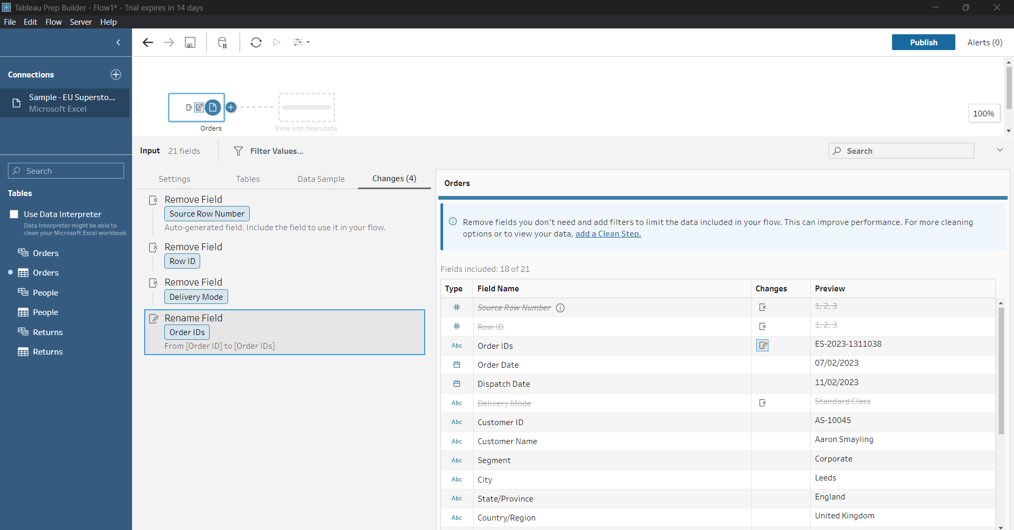
* We can delete, remove, rename, hide column
* 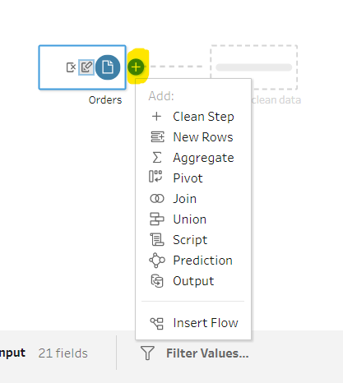
* 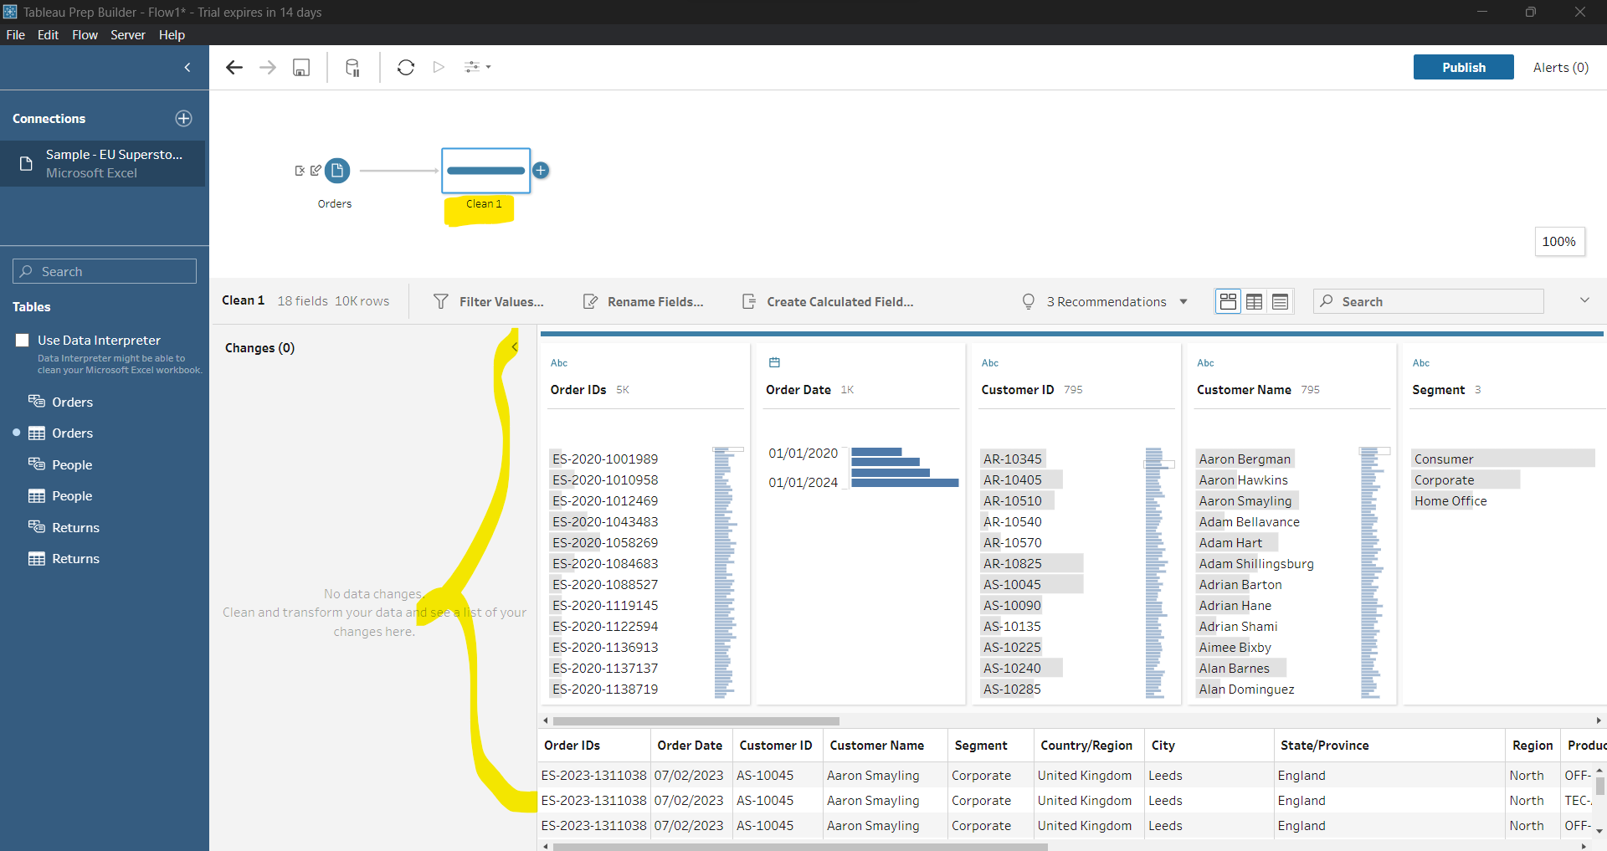
* 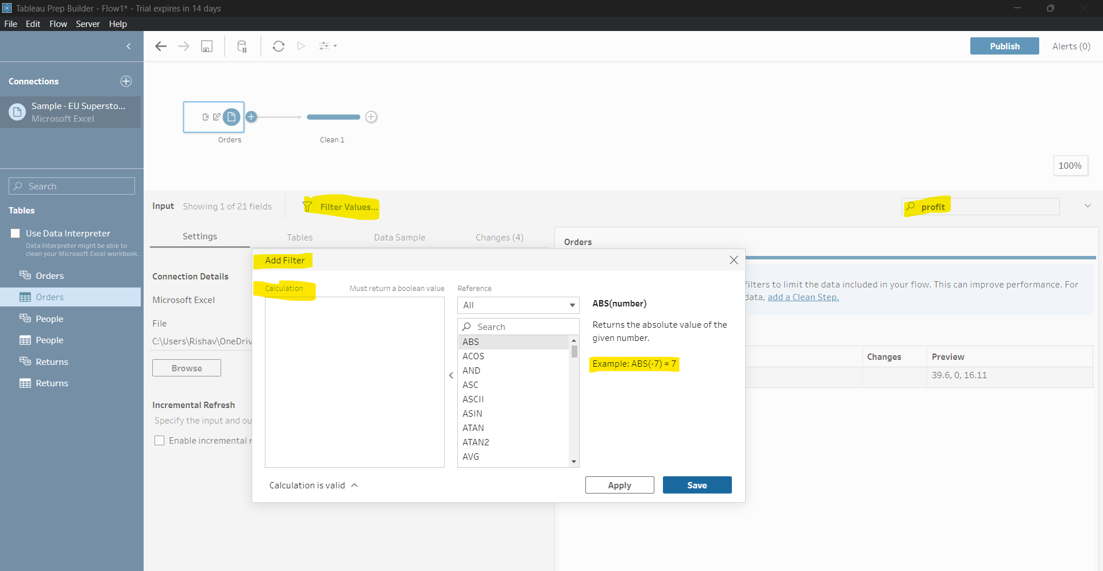
* In search we can search for column. Filter me kuchm calculation karte hai. It will return yes/no or true/false or Boolean value.
* 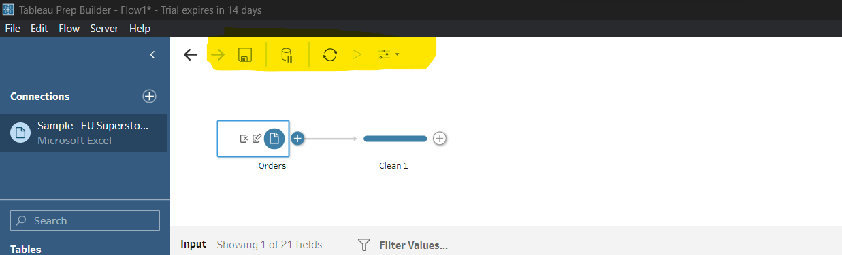
* Save, Update Pause, Refresh Data, Run all flows, Parameters
* Workflow in 2 format -> .tlf and .tlfx
* .tlf me sirf skeleton share hota hai
* .tlfx me data bhi saath me share hota hai.
* Tlf= tableau flow
* Ye automatic kuch hud tak data clean kar dega.
* 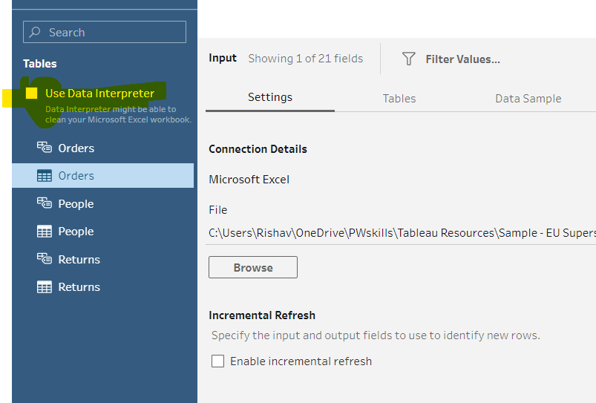
* We can remove fields from this way also. 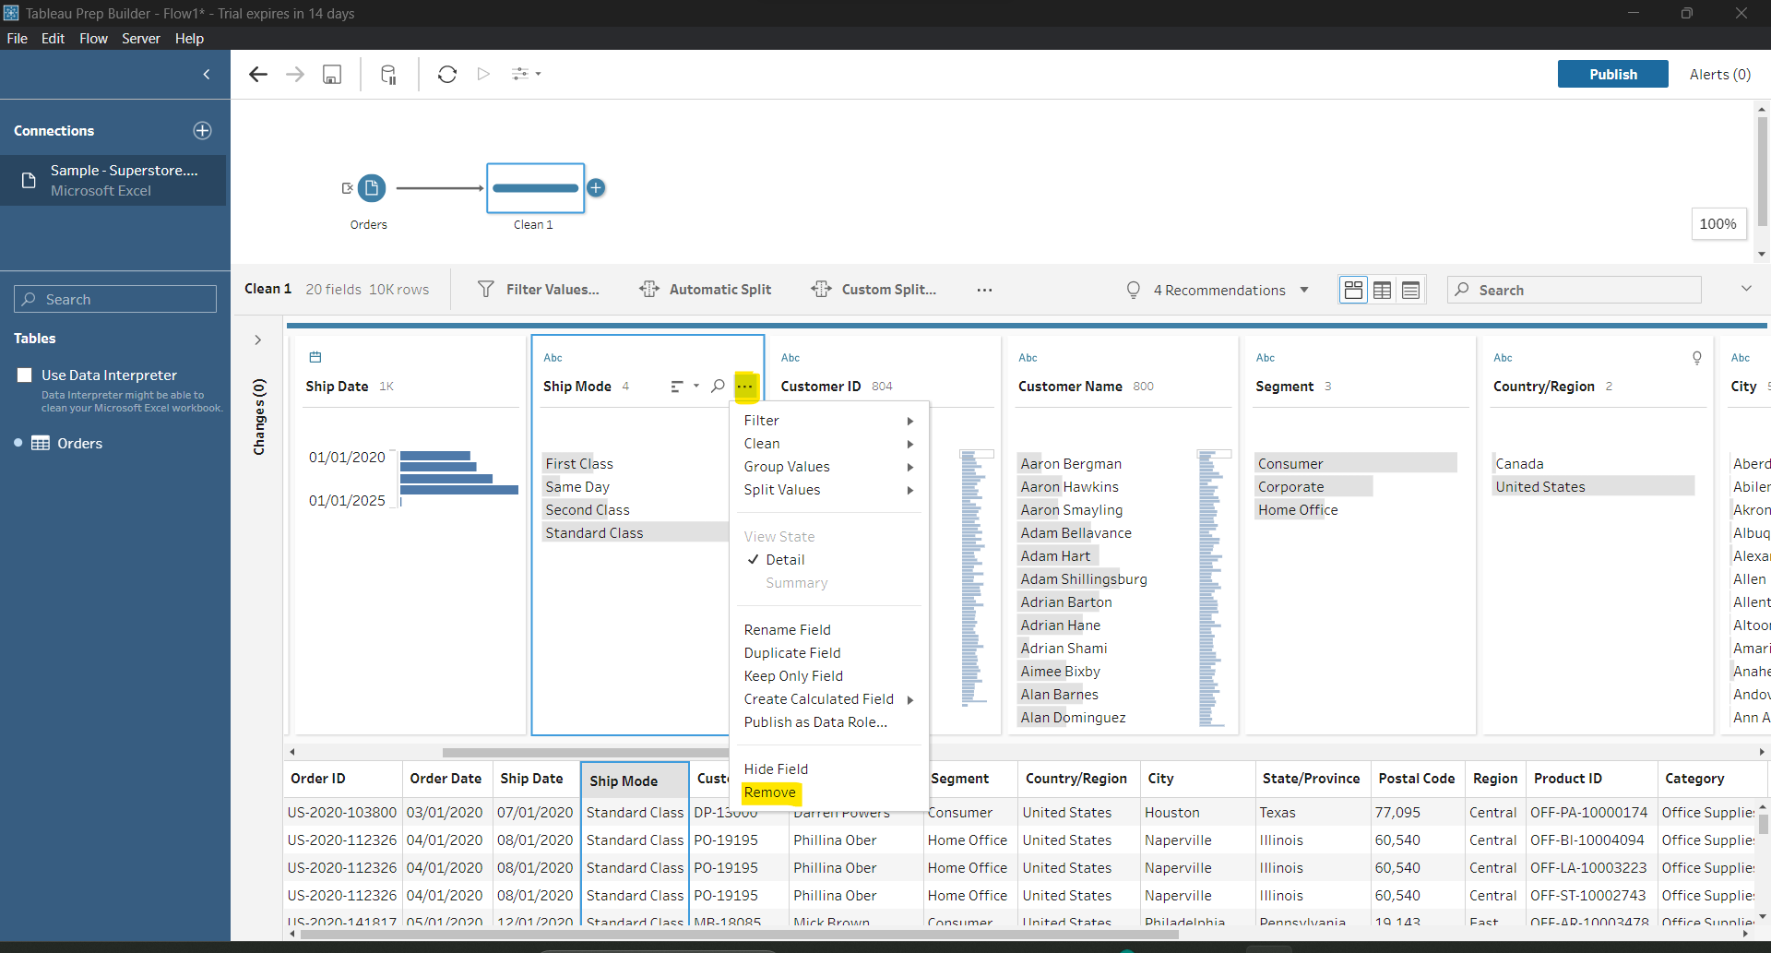
* 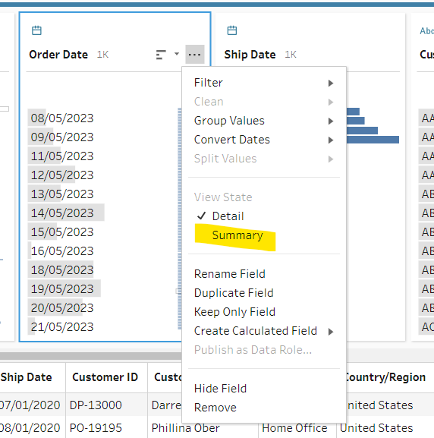
* Summary is specific to some column only.
* 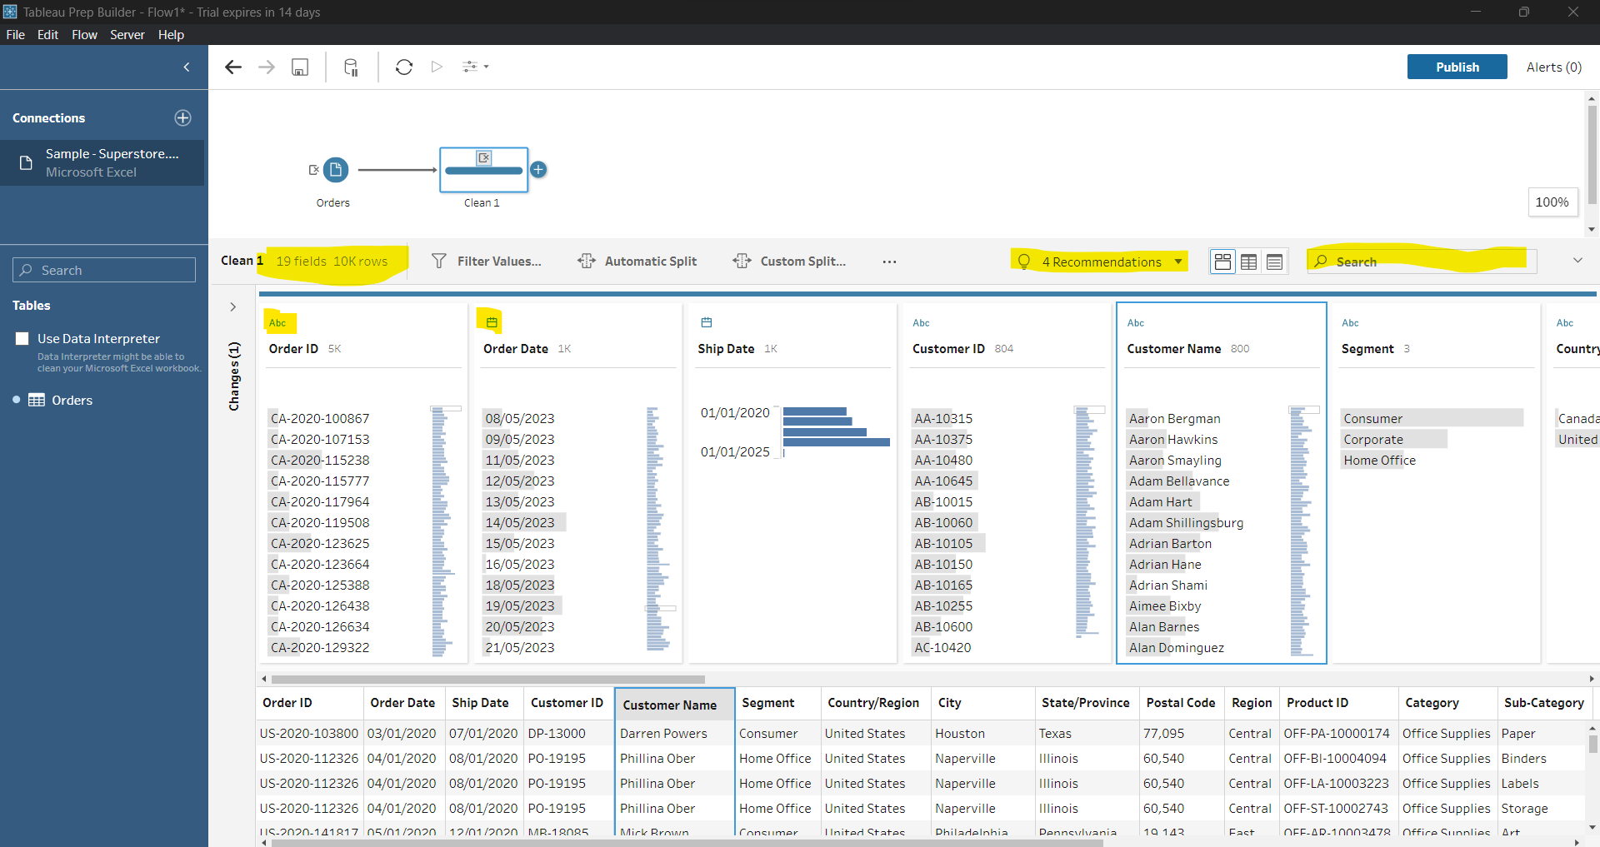
* We can change data type.
* Undo and redo ctrl+z ctrl+y
* 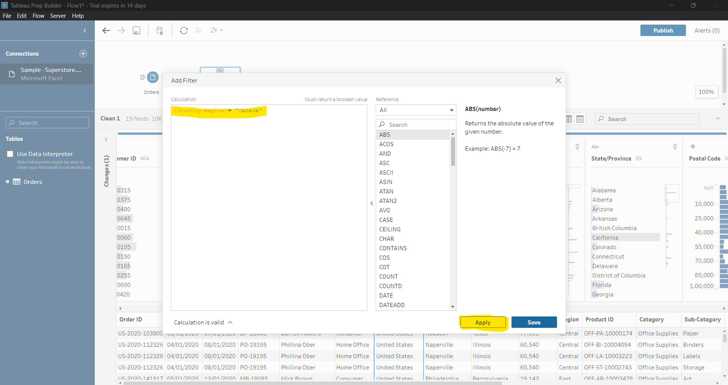
* Create Calculate Field : Used to merging column like date.month,year
* It is also used for applying some condition in workflow.
* MAKEDATE([year],[month],[date]) :create a date column
* Change data type
* It will help to remove something from column. 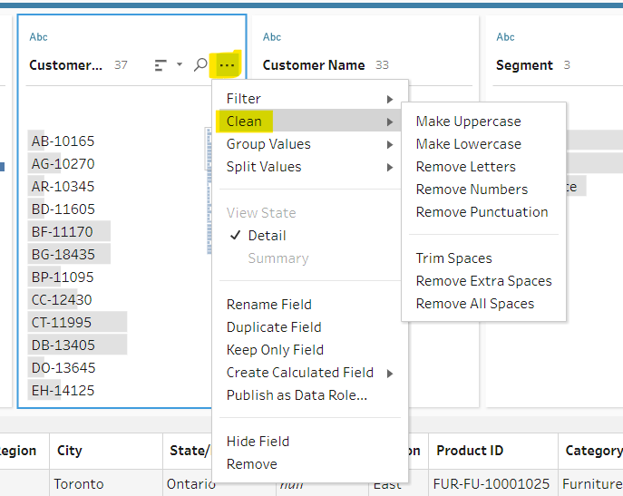
* Tableau data type recommend karti hai. Agar koi value invalid hai jaise ND, KNP to invalid ko filter karke uske New Delhi, Kanpur se replace kar sakte hai. Just double click and enter valid name.
* Jo name multiple time honge wo group ho jaayega uske left me clip ka icon dikhega.
* Split: Automatic and custom split. Split kisi deliminiter ke basis pe hota hai.
* 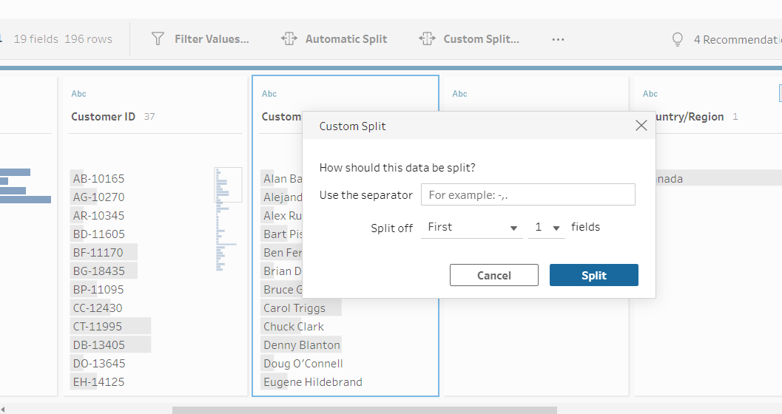
* We can remove letter from order id to get only numeric part.
* Double click on any text to modify it.

355. Data Preparation Using Tableau Prep Part-I

* Connect data sample superstore
* 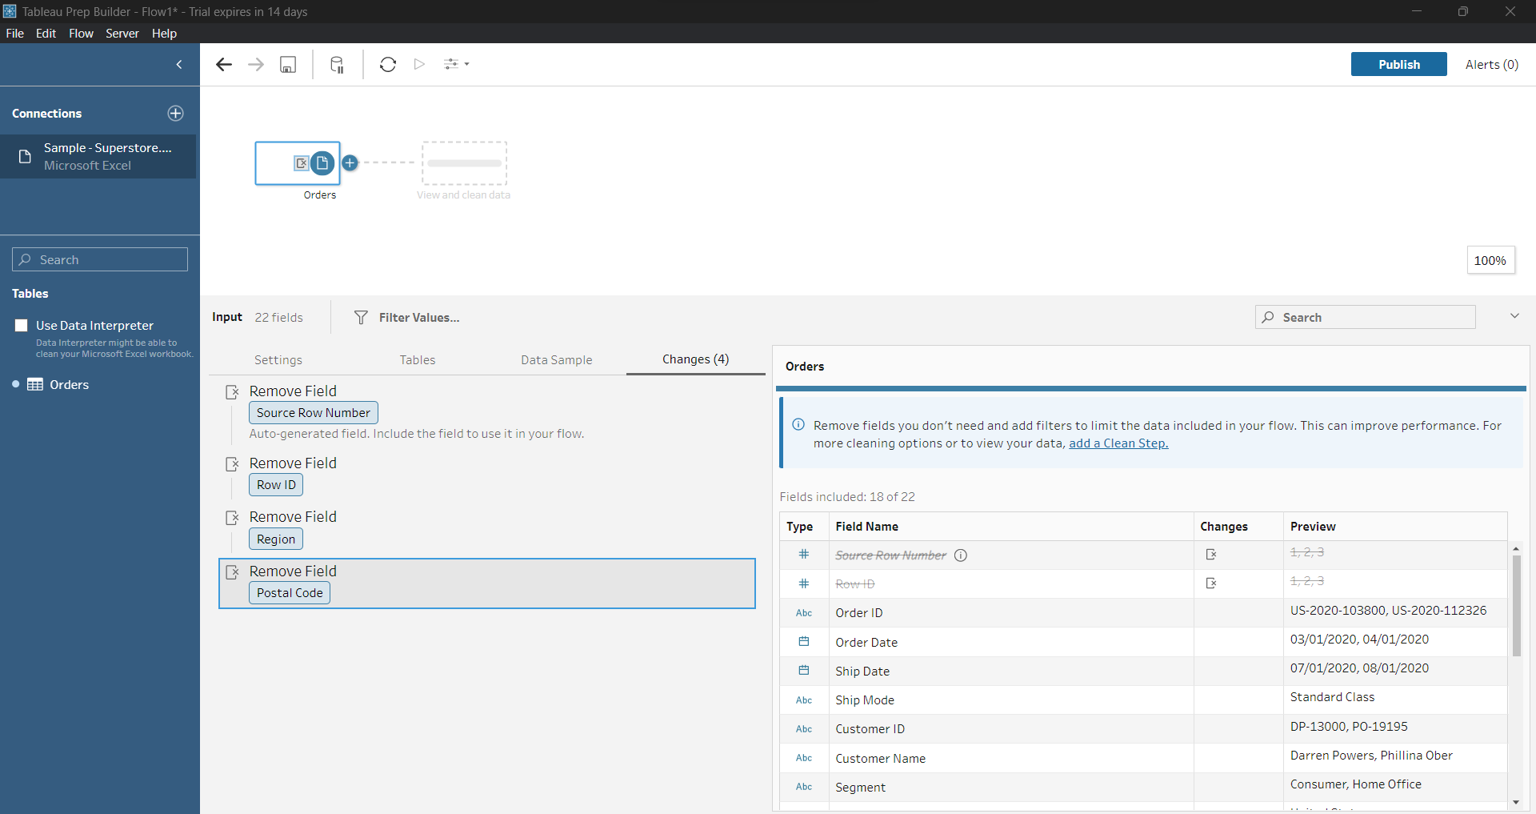
* Add clean step
* Remove ship mode
* It will show data only for Canada. 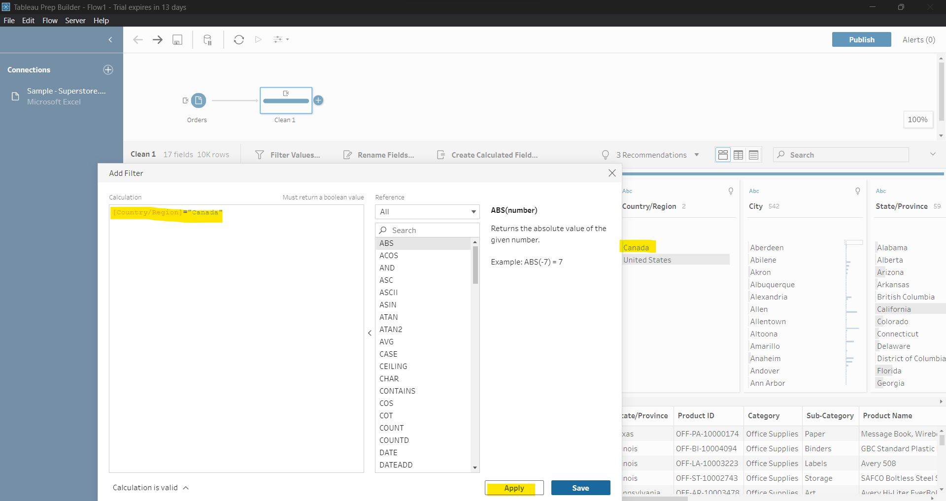
* Ctrl + z = undo
* 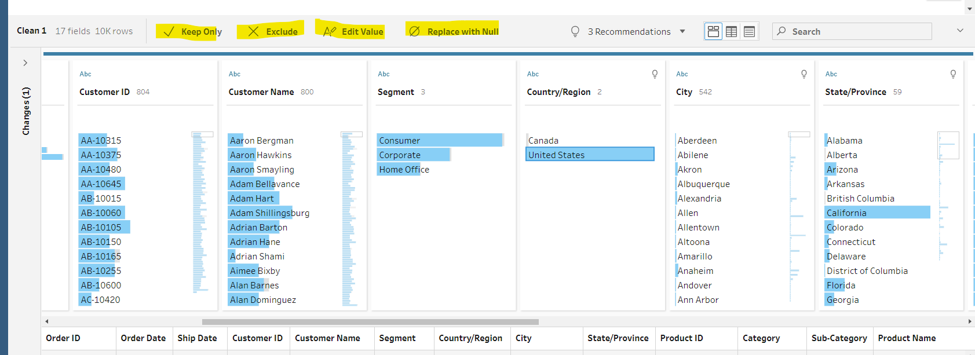
* Keep only : filter Exclude: exclude kar dega Edit Value: change value Replace with null: null replaced
* Refer this file for small data analysis. 
* Open this file in tableau.
* Add clean step 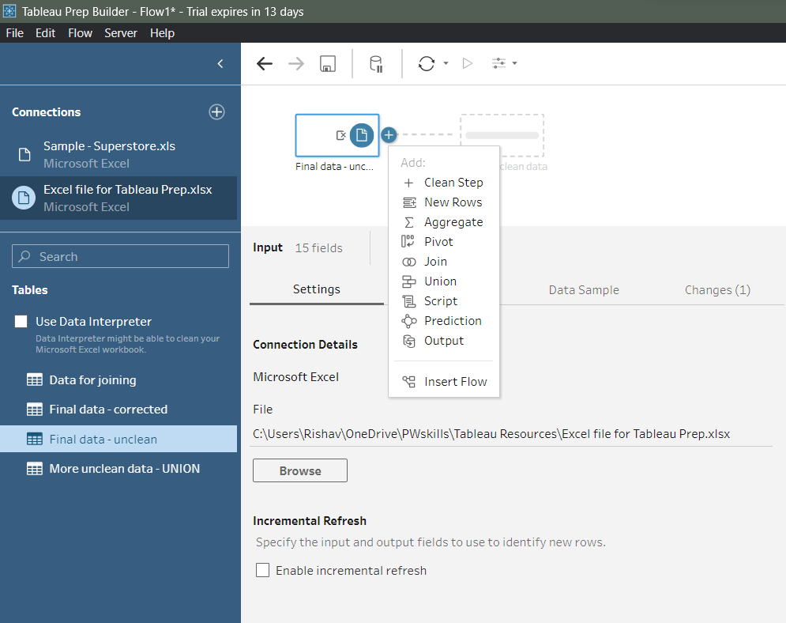
* Add a Order Dates column and remove order year,date, month column. Hi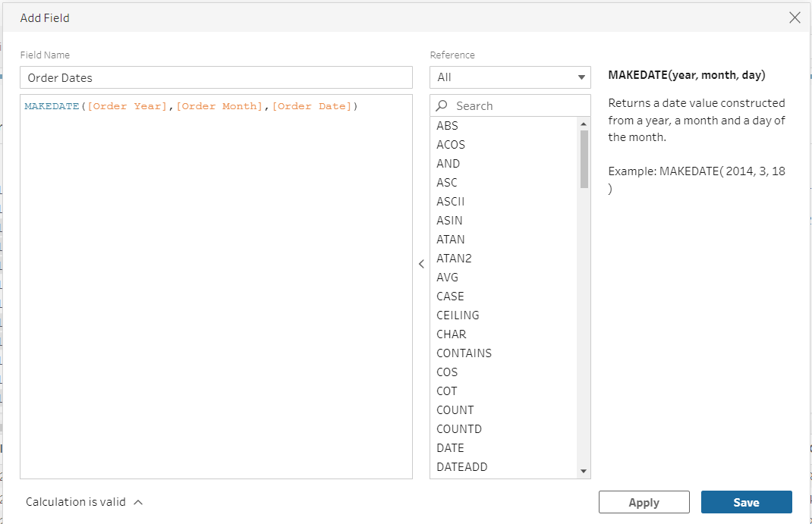
* Hint: Use Create Calculated Field.
* This is showing formula applied on this column. 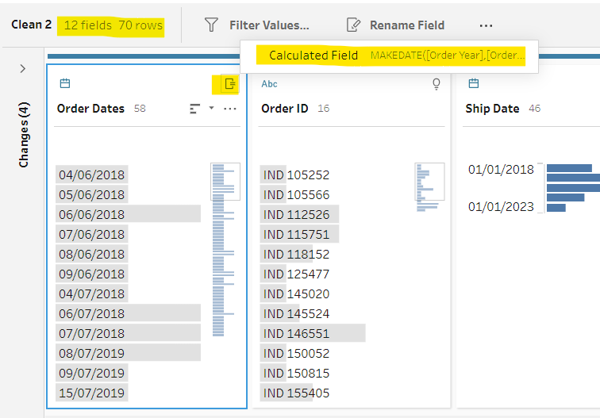
* Cost Price ka data type abc show kar rha hai. Aisa q ?
* 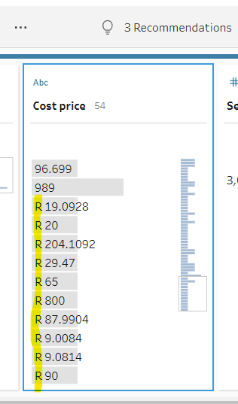
* So, we have to remove letters from it. 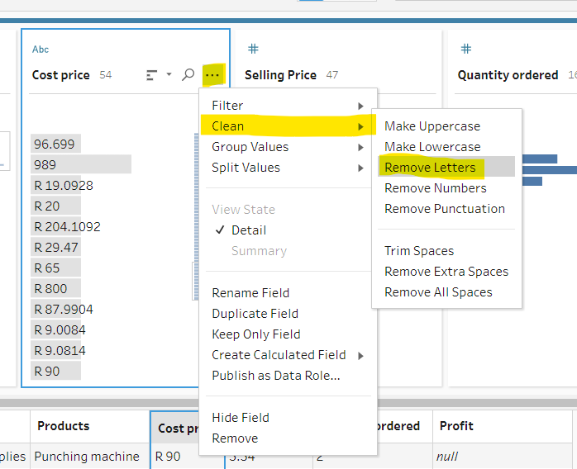
* Now change its data type to whole no.
* Ascending, descending kitni count hai uske hisab se hoga.
* Change country data type. 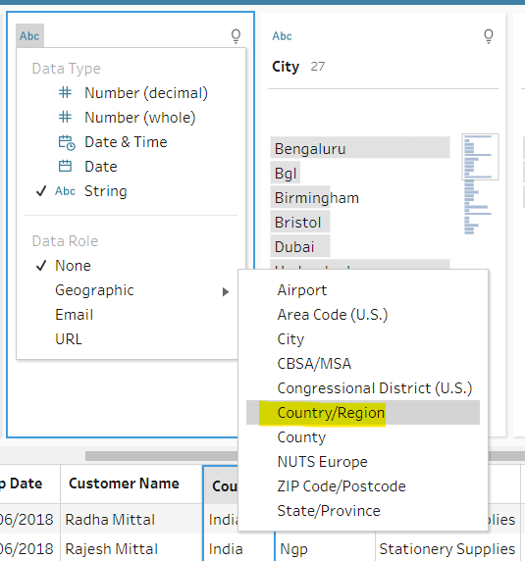
* Change for city to city. But we have some red flag invalid data. 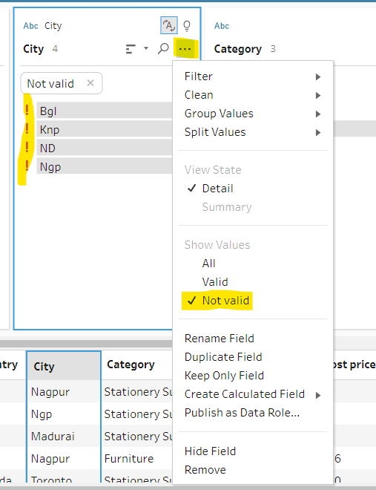
* Is subko double click karke change kar do.
* This is indicator what we have done. 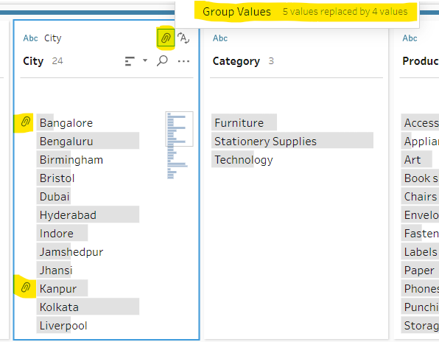
* This will separate IND and numeric part. 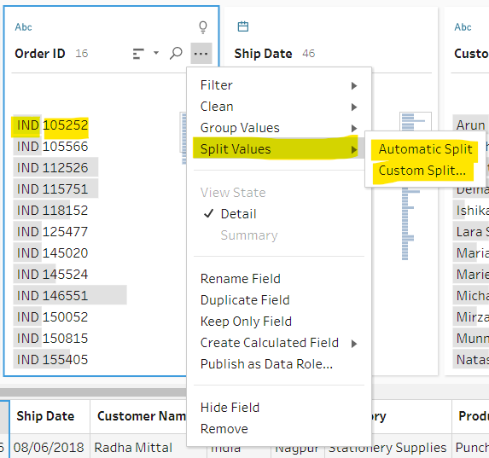
* 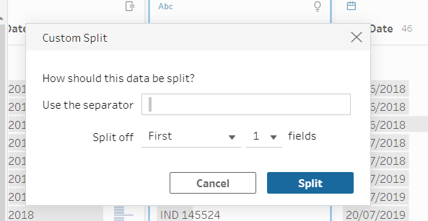 o/p 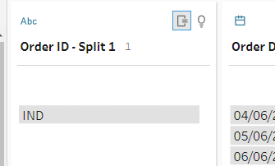

Lec: 356 Data Preparation Using Tableau Prep Part-2

* Union and Join
* Union me table me data add hota hai. Join me common column ke basis pe data filter hota hai.
* For union data gets taller, datatype should same, both table should have same structure.
* For join table gets wider, data type may or may not same, at least one common column.
* We use this data for joining or union. 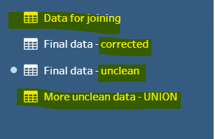
* Unclean ko humne clean kar lia last lecture me ab ussi se join or union karenge.
* Now add more uncleaned data to workflow space and check for some cleaning. 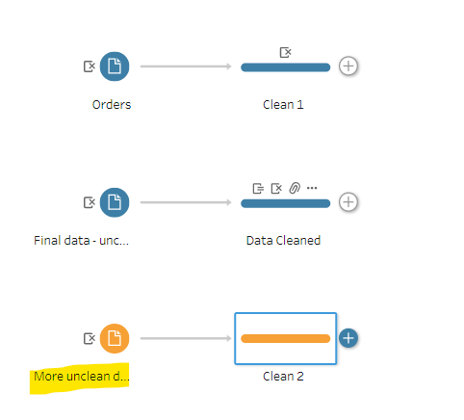
* 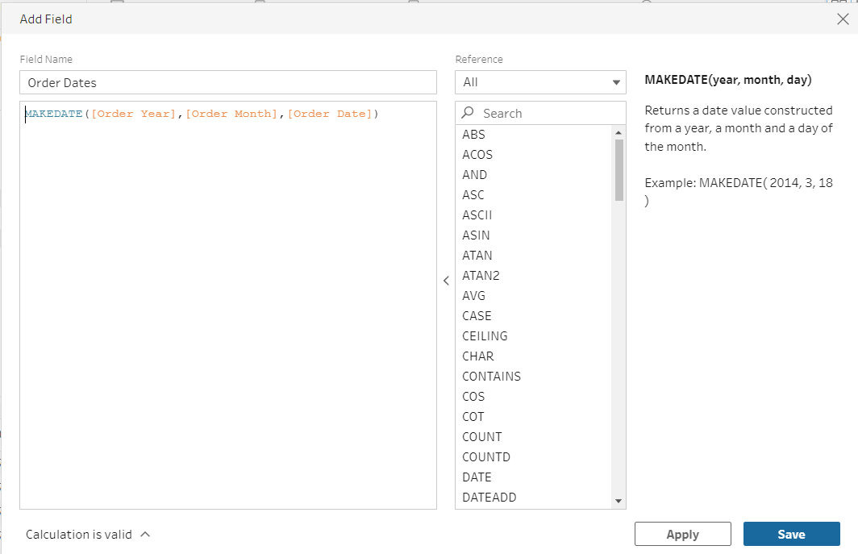
* Remove year, date, month column
* Recommendation me jo hai split order id ko chod ke baaki dono ko apply kar do.
* We use final data corrected and union sheets for union operation.
* Final Data corrected and Join sheets for joining operation.
* 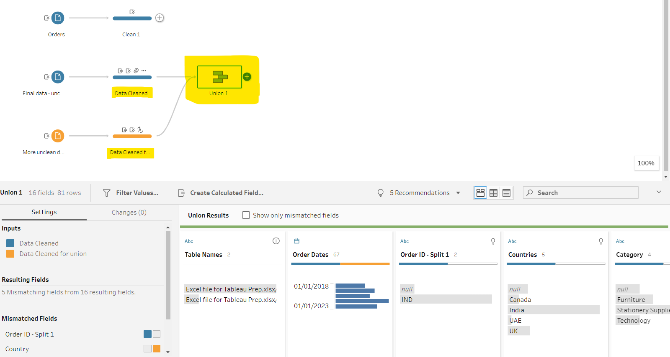
* Niche wale ko drag and drop karne hai middle wale pe union karne ke liye.
* Fix mismatch columns/values. 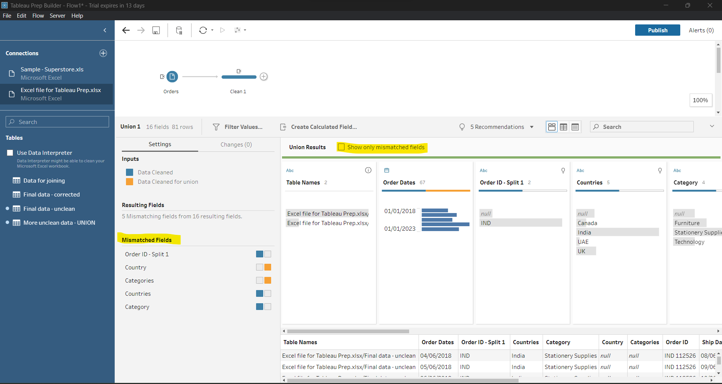
* Remove Order Id
* Countries have more data than country so drag country and drop to countries column.
* Drag from yellow part and drop to yellow part. Means mouse pointer should be from yelloe to yellow part.
* Similarly do for categories.
* Rename union of cleaned data. 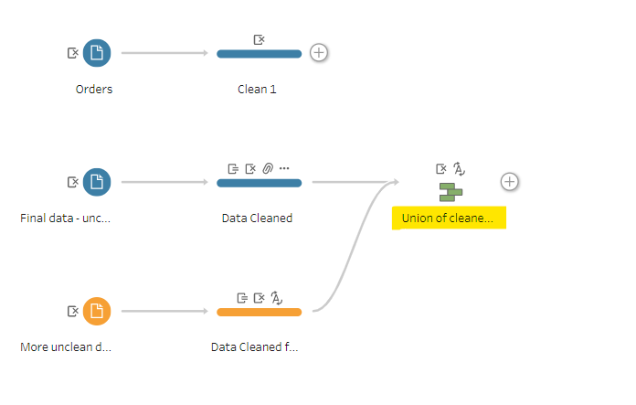
* Take join sheets into workflow area and do some cleaning then join it.
* Here no cleaning required so, we can remove clean steps from diagram.
* Wow now our diagram. 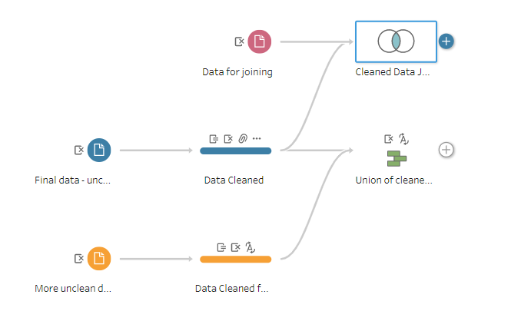
* Explore these window upon clicking on Cleaned Data Joining. 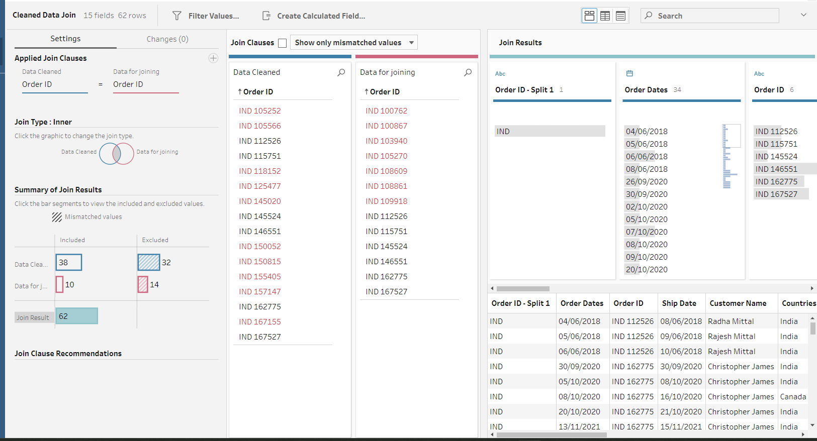
* Is window me bahut cheez likha hai, samjho isko ache se.
* We can do some cleaning after union and join as well.

356. Data Preparation Part-3 Aggregation, Pivoting, Saving Flow And Output.

* Aggregation : Bahut saari value ko combine karke ek single value banana.
* SUM, Average, Count, Min, Max, is aggregation functions.
* Work on sample superstore cleaned data. 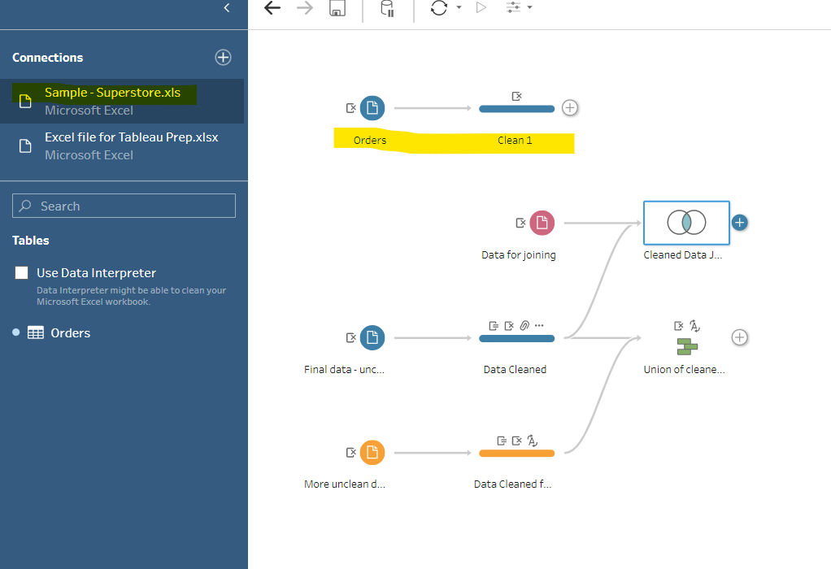
* Add aggregation branch.
* 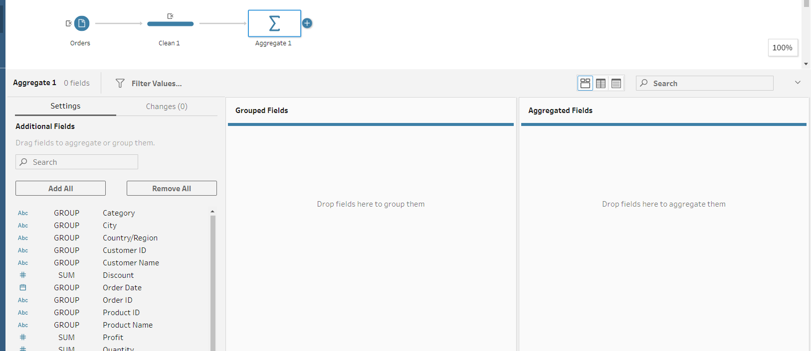
* Aggregated fields me numeric data le jaate hai, whi grouped fields me text data le jaate hai.
* Sum waale pe double click karne pe wo automatically Aggregated Fields me chala jaayega, whi Group wala grouped fields me.
* We can drag and drop for adding and removing from fields.
* 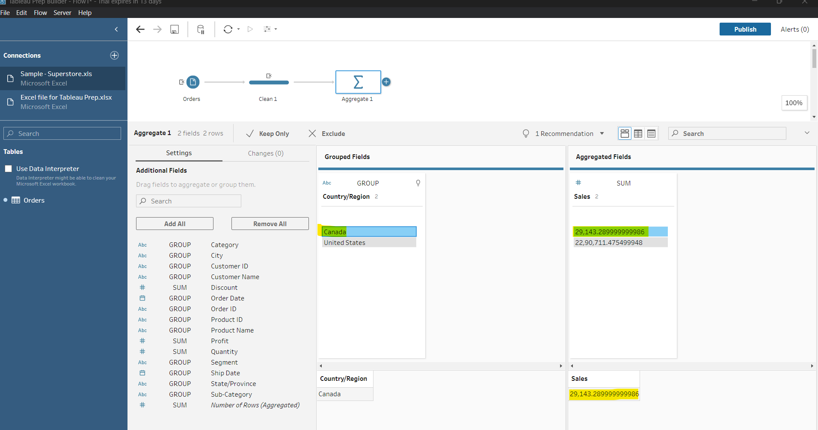
* Ye highlighted sirf Canada ka data bta rha hai.
* Basis of more than one column data. 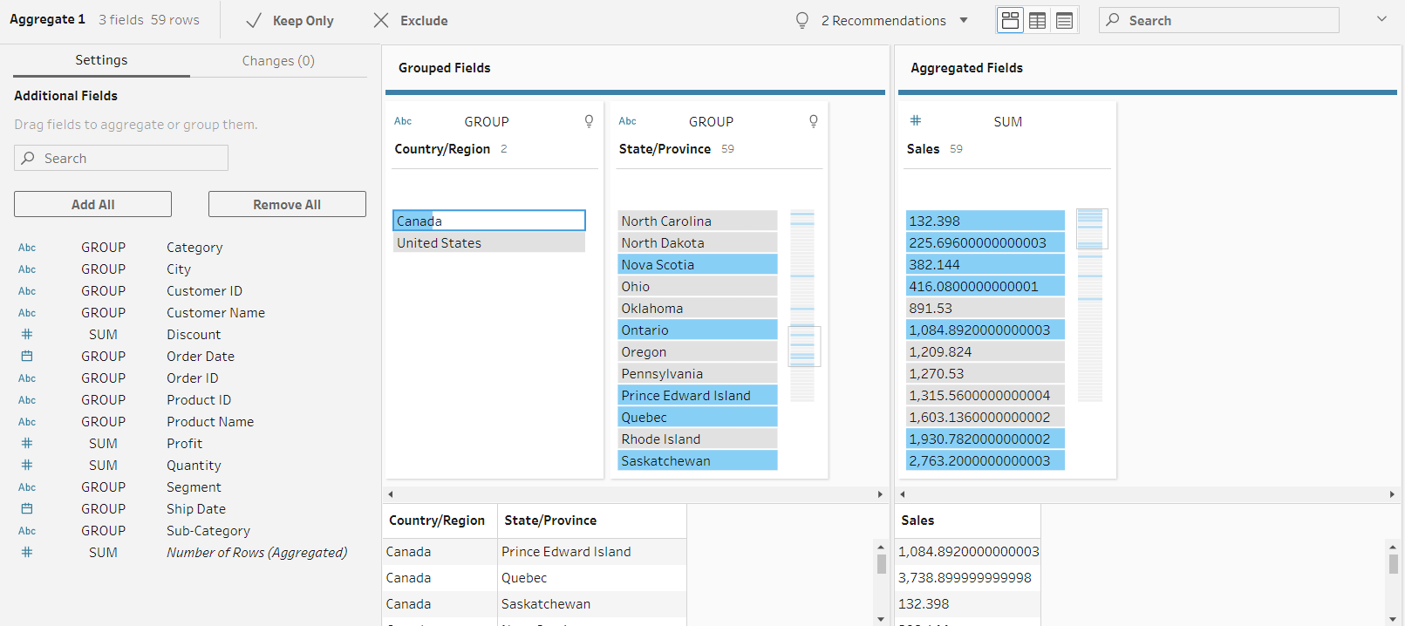
* 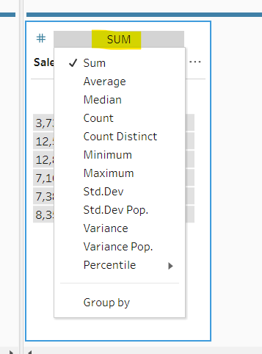 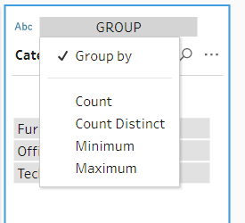
* Now, join aggregate and cleaned data. 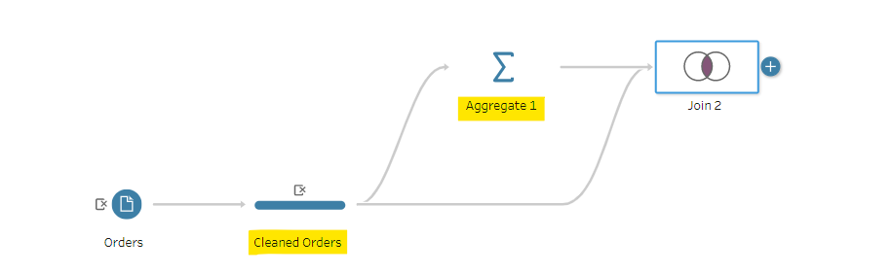
* Abhi join quantity pe hua, but no data shown. So we will join on other column.
* 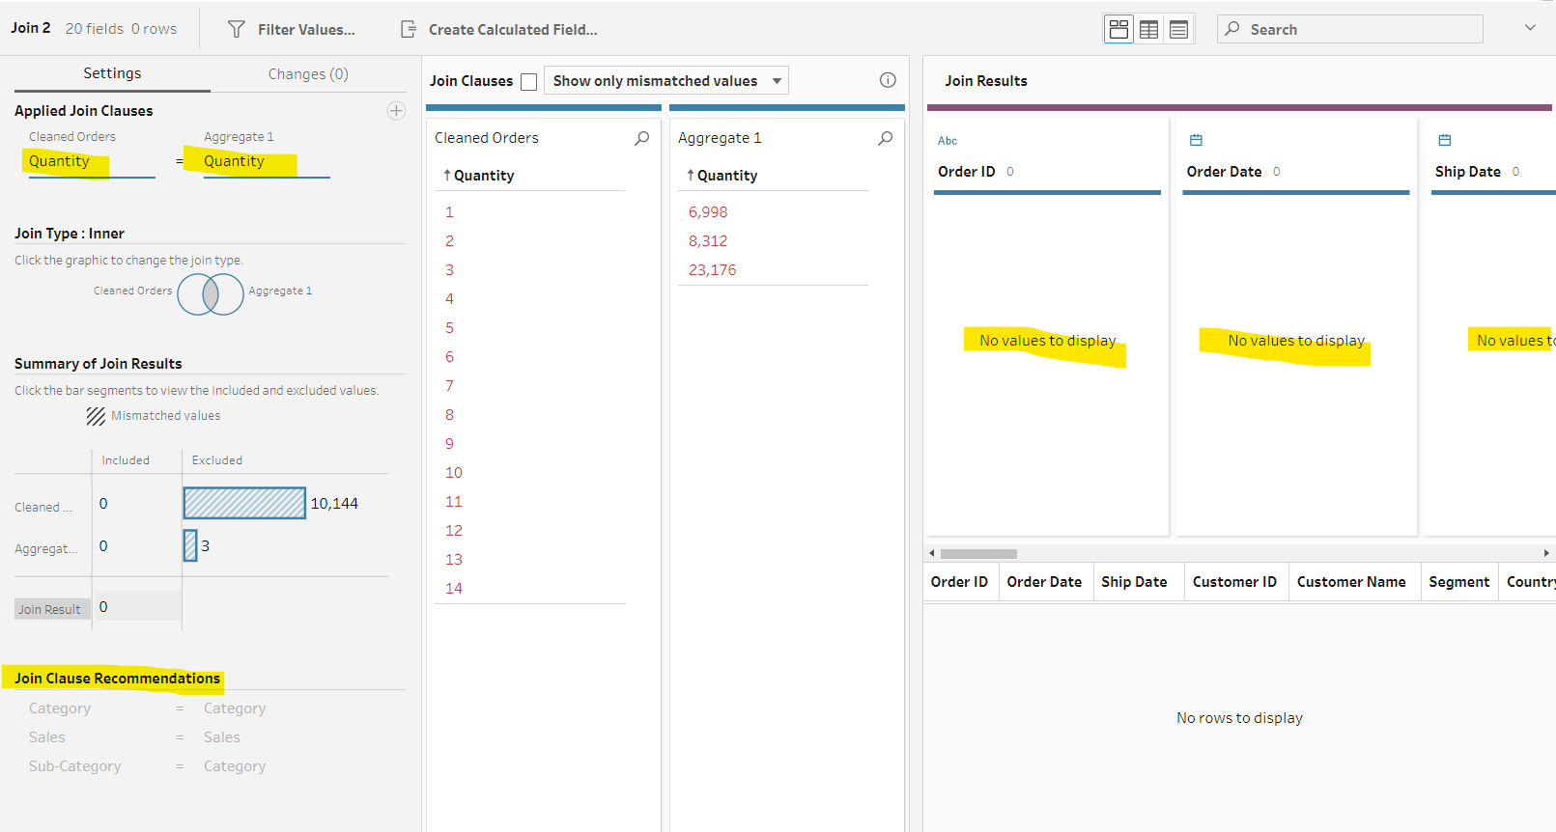
* 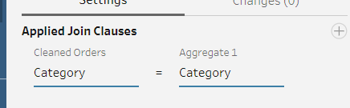
* Now, add a cleaning step and do some cleaning.
* 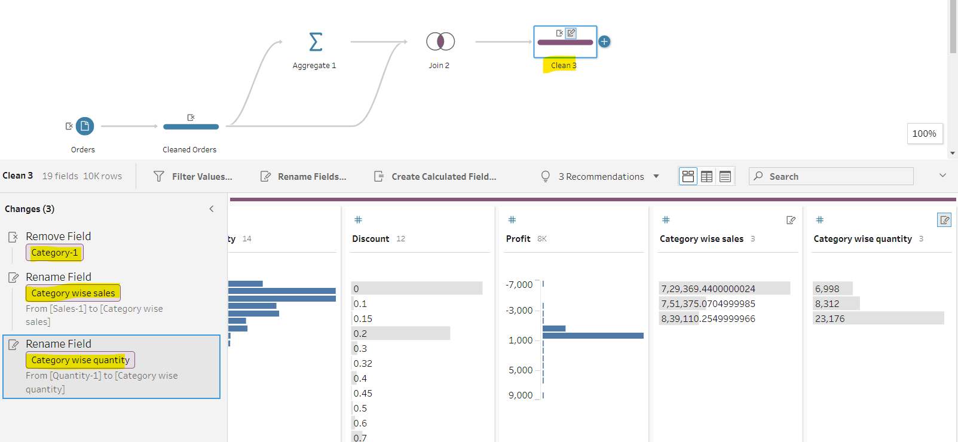
* Do category column hoge aur value same hai to ek ko remove kar denge.
* Sales and quantity bhi do hai to last wale ka naam change kar denge. 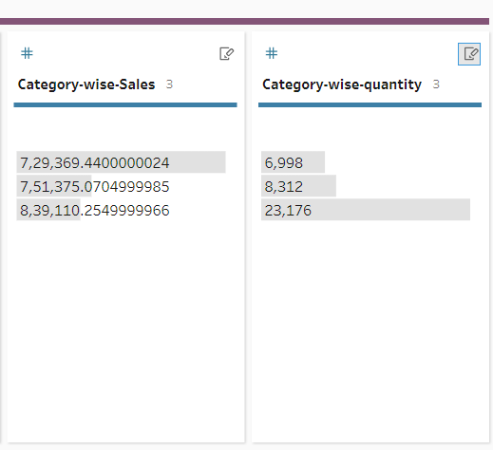
* We can show these data in Tableau Desktop. 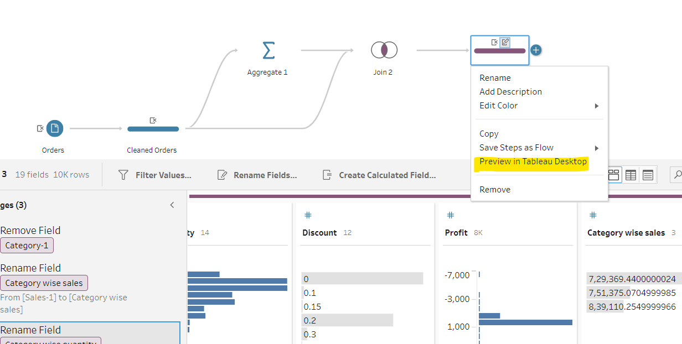
* Pivot: Kisi cheez ko dusre perspective se dekhna. Data ko summarize karna. Rows ko columns me convert karna.
* Un-pivot means columns ko row me convert karna.
* We will use this sheet. 
* Add connection and use this excel sheet.
* Add New Data Sheet in workflow area.
* 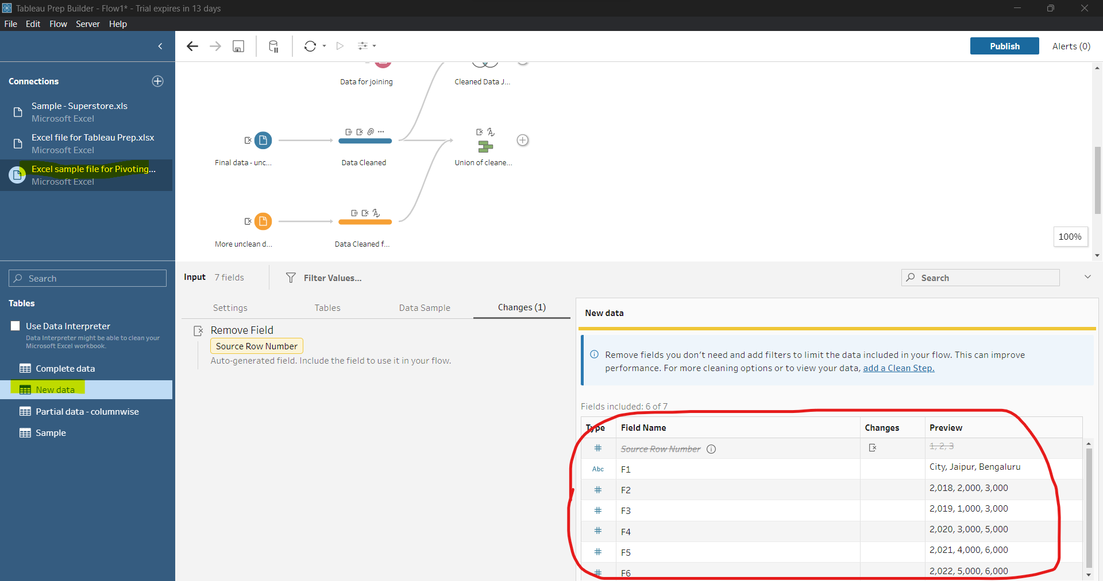
* Ye to kuch gadbad hai. F1, F2, F3 sheet me to nhi dikh rha tha.
* Check this, it will solve. 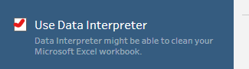
* Now, better 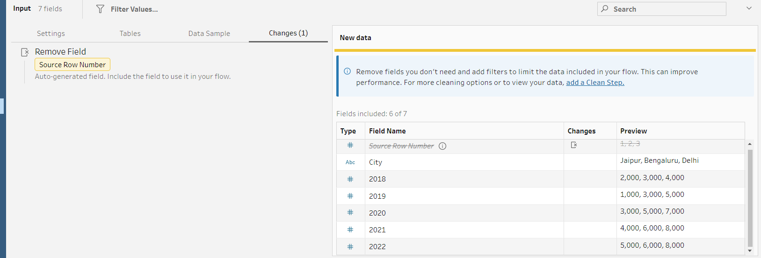
* Add a cleaning step.
* 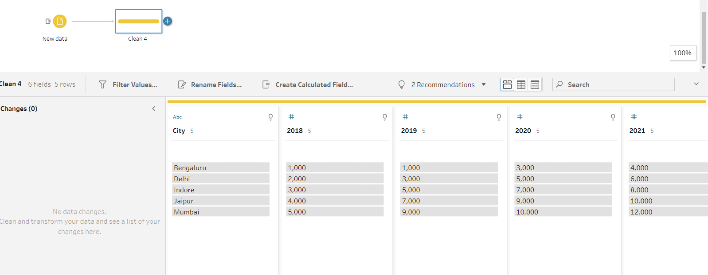
* Add a pivot step. 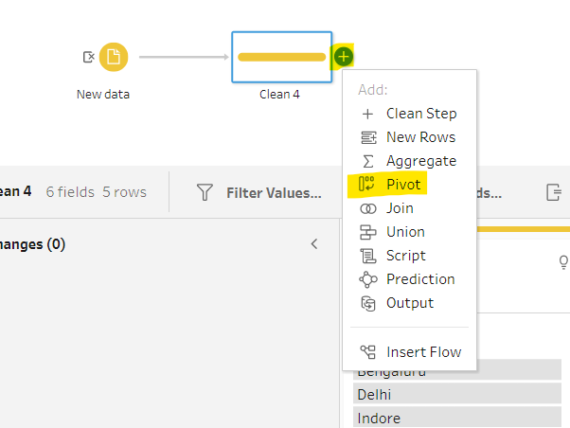
* These r pivoting and un-pivoting.
* 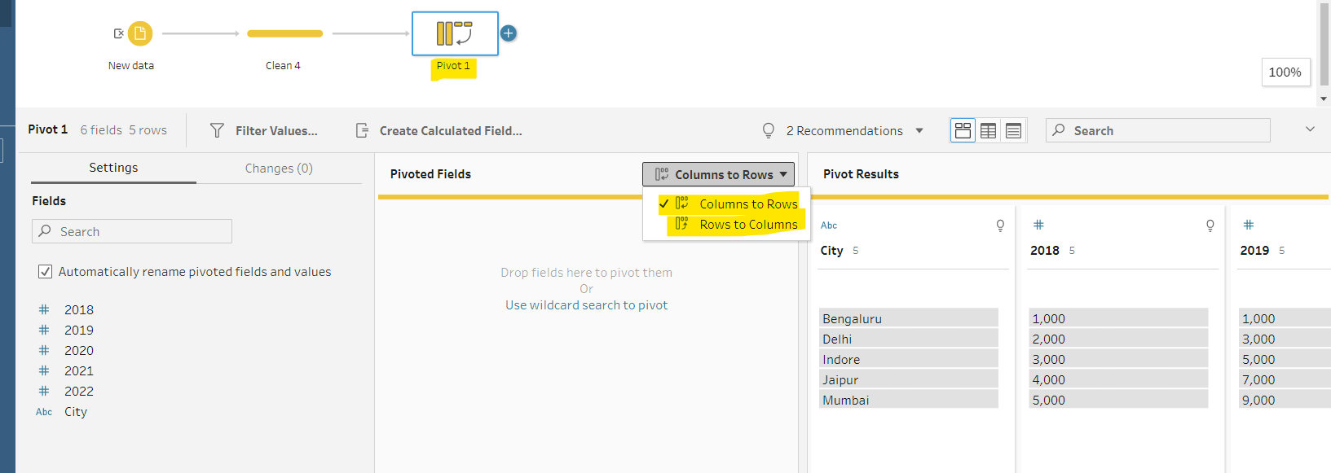
* Click on 2018 and shift + click on 2022 and drag and drop to pivoted fields.
* Add a cleaning step to see how our data looks like.
* 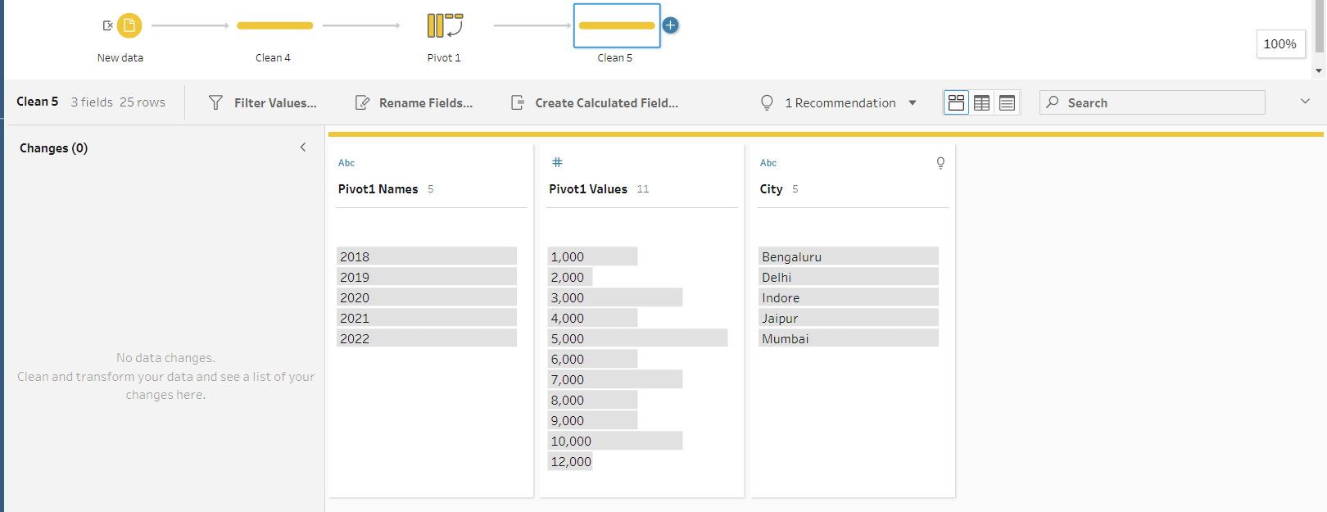
* Rename fields. 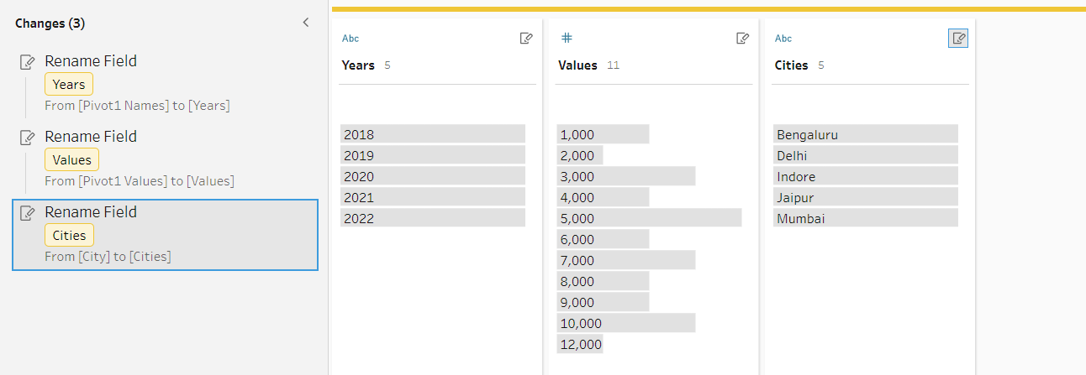
* 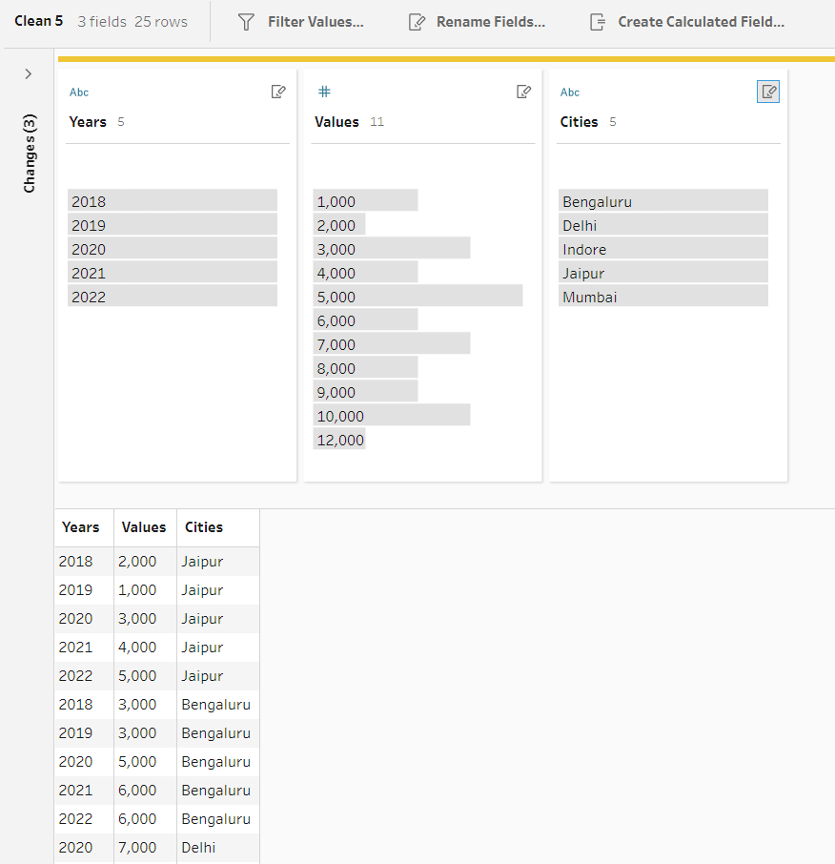
* Ab is sheet ko wokflow me add karenge aur long data ko wide karenge. 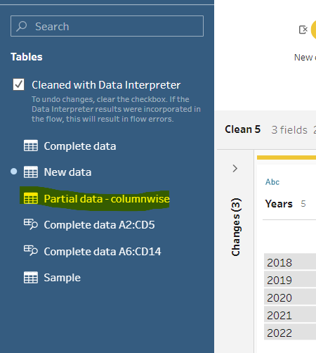
* Add clean view branch and see content of this sheet.
* 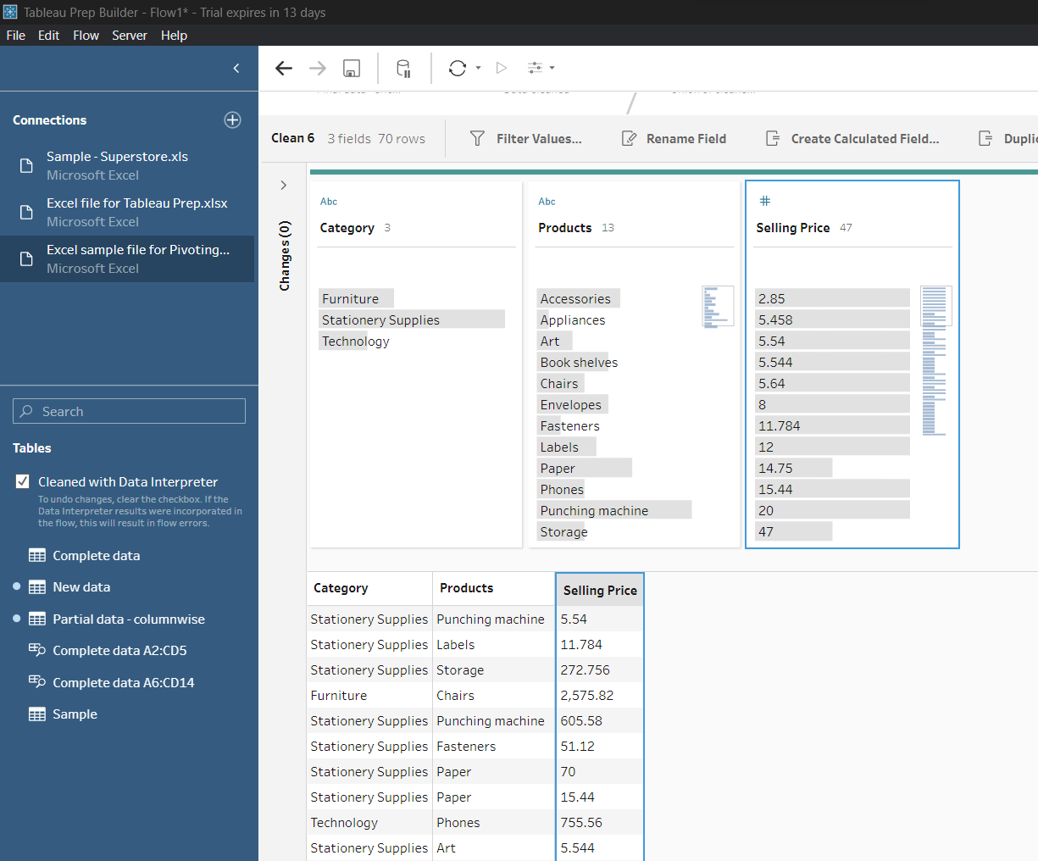.
* Add pivot branch.
* 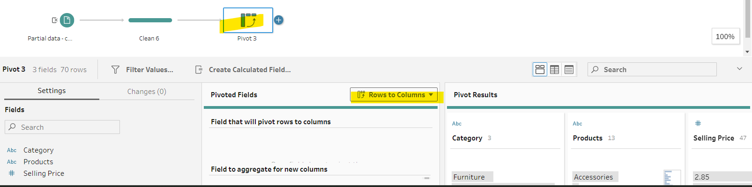
* Ek baar me ek hi columns ko pivoted Fields me add kar sakte hai. Dusro ko karna hai to pehle ko remove karna hoga.
* Products ko pivoted me move and selling price ko Aggregated me move karo. 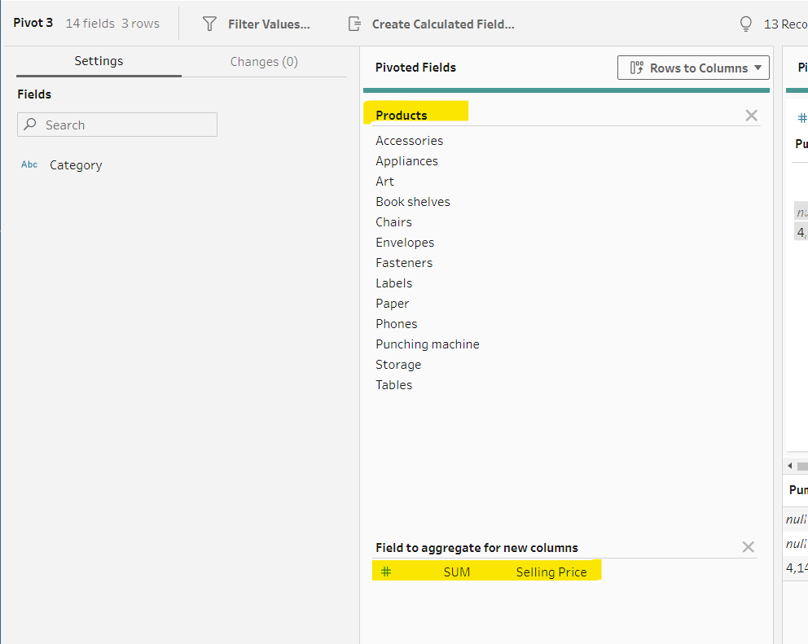
* Add a cleaning step and see how data looks like.
* 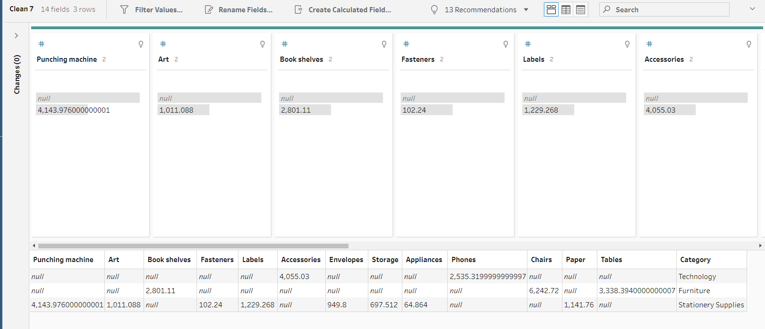
* We can do this things in tableau desktop as well.
* Now, we will convert this wide data to tall data.
* 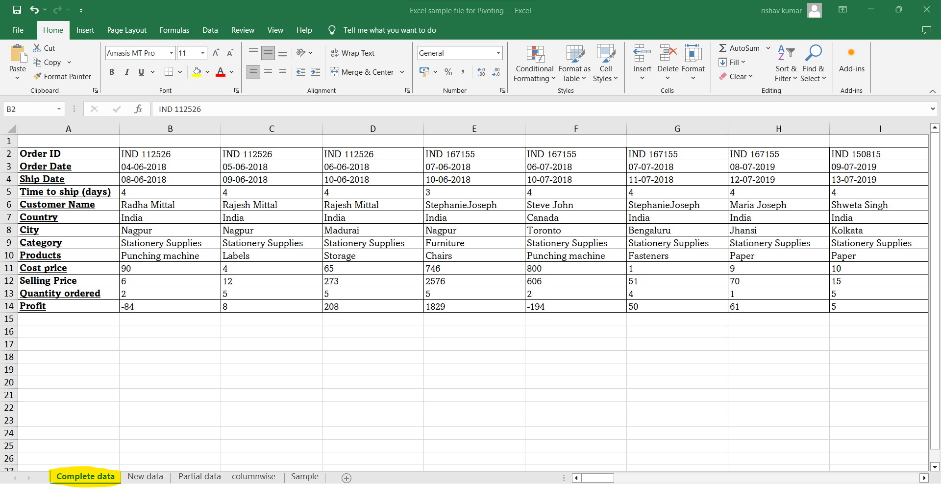
* Add connections -> import to workflow area.
* Add a cleaning step to see data.
* 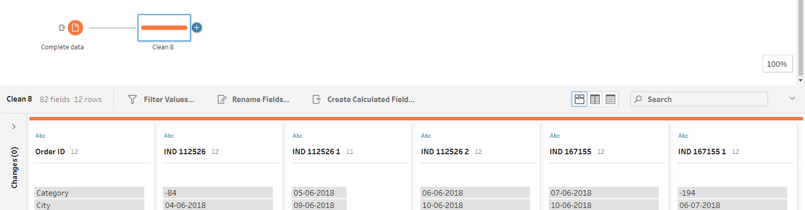
* Add pivot branch.
* Select all order id and dgrag and drop to pivoted fields area.
* Add a cleaning branch see our data. Do some columns name changes.
* 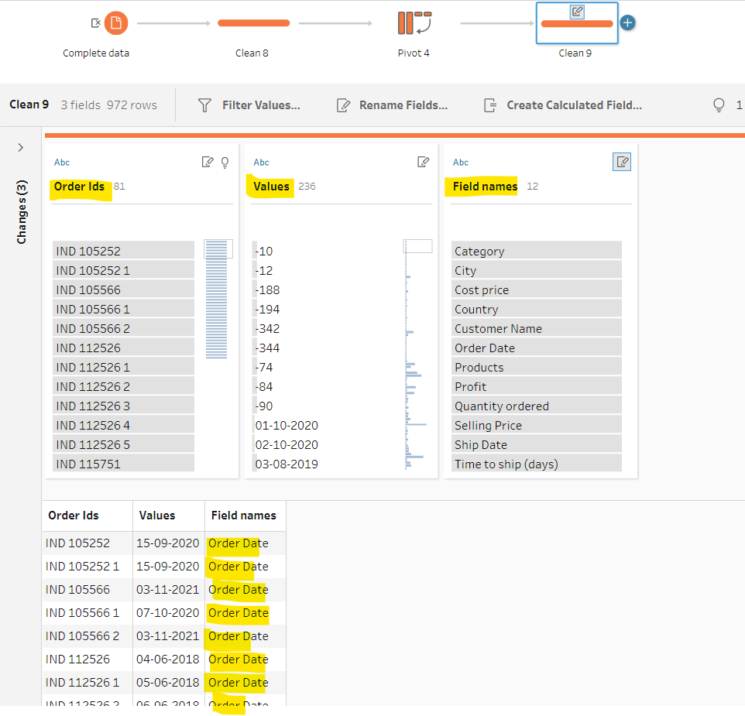
* Now, goto flow-> Run All -> Click on save icon
* Click on run all. It will be saved and double click on it will directly open in tableau desktop. 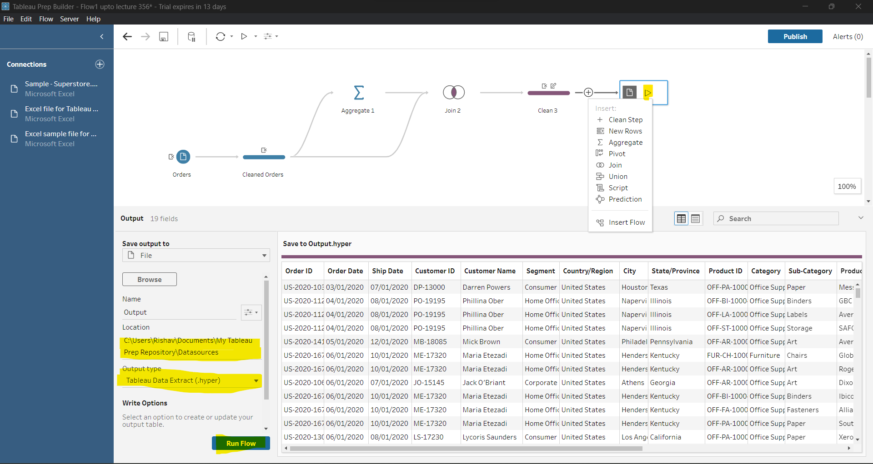
* O/P file generated. 